CPSC 535 Day 2 8/24/2022

1. Big-O Notation  
   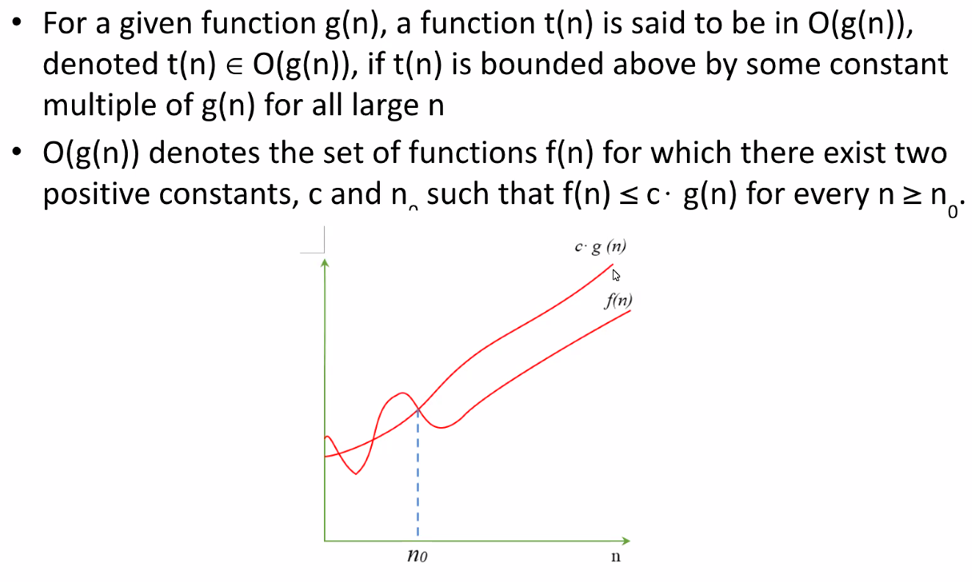
   * 1. Next Monday’s exercise will be about Big-O Notation
   1. Exercise (Sample)  
      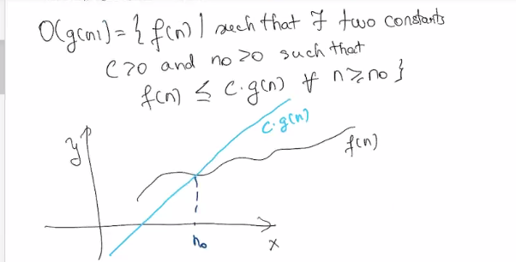  
      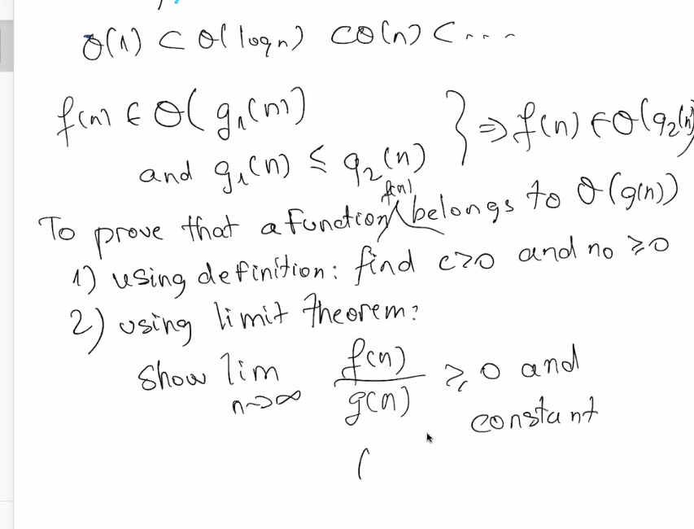
2. Solving a problem
   1. 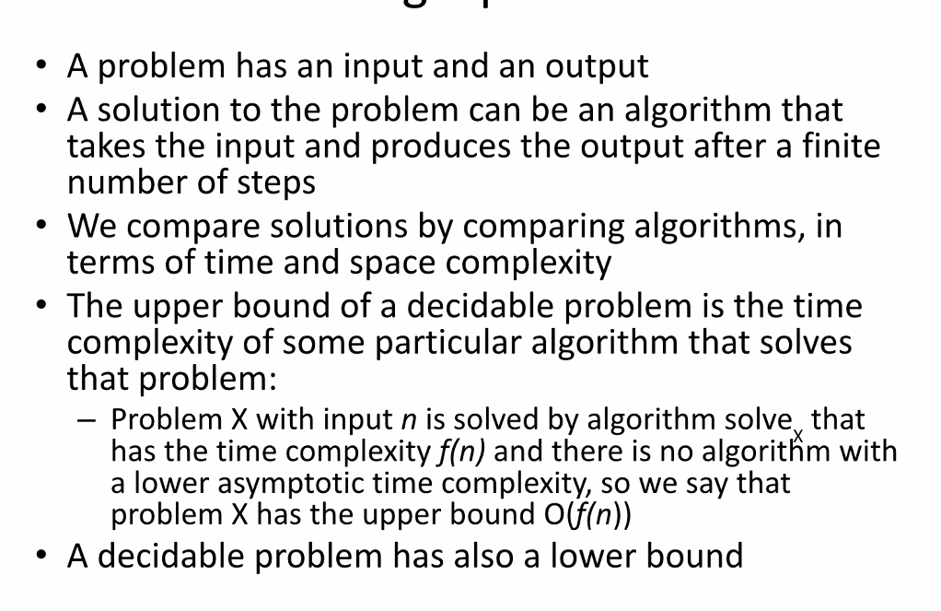
3. Lower bound of a problem
   1. 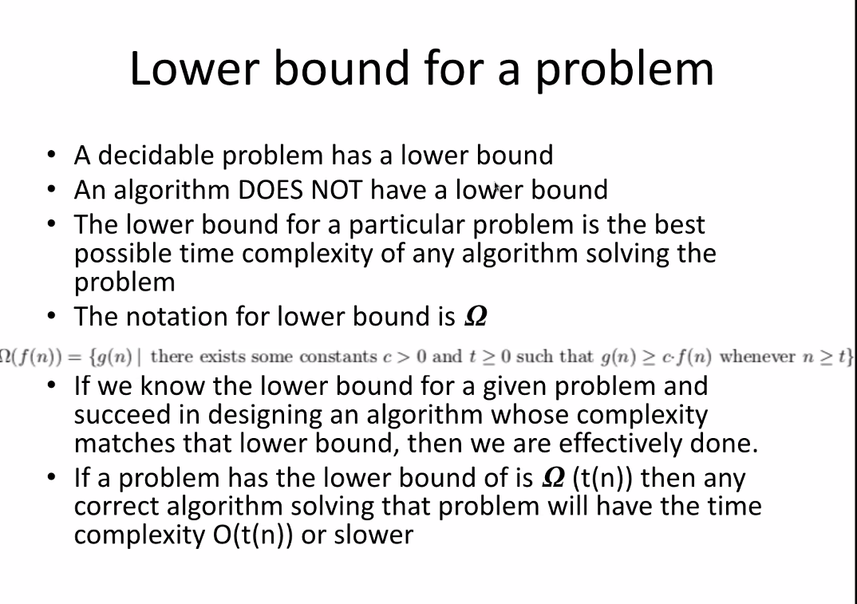
   2. Most important part: algo does NOT have a lower or higher bound
      1. Just time limits
   3. Omega = for any algo that solves problem, but show a minimum of omega steps
4. Tight bound
   1. 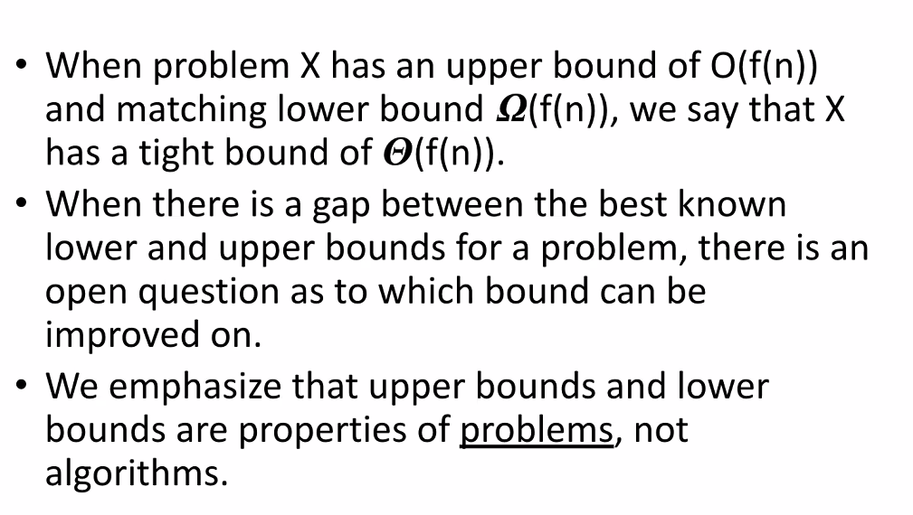
5. Trivial lower bounds in general
   1. 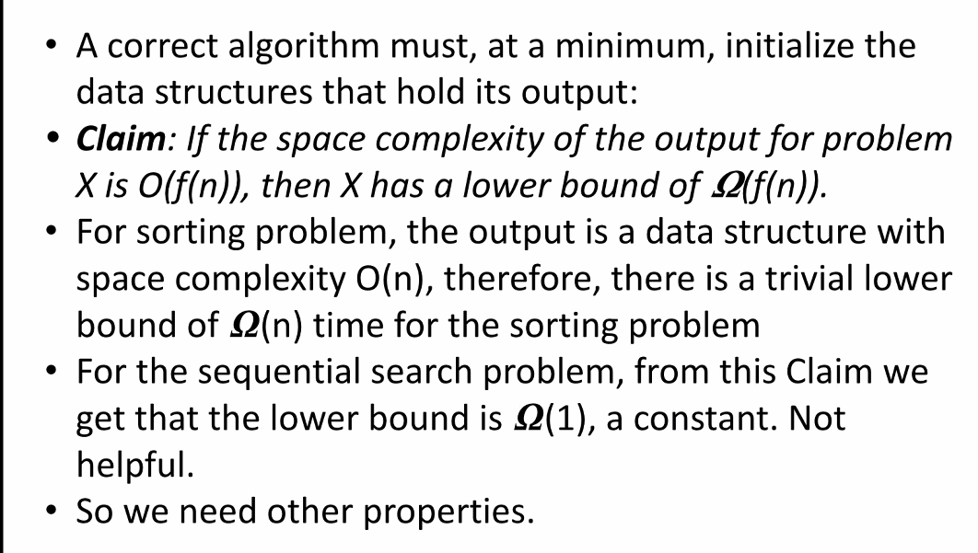
   2. 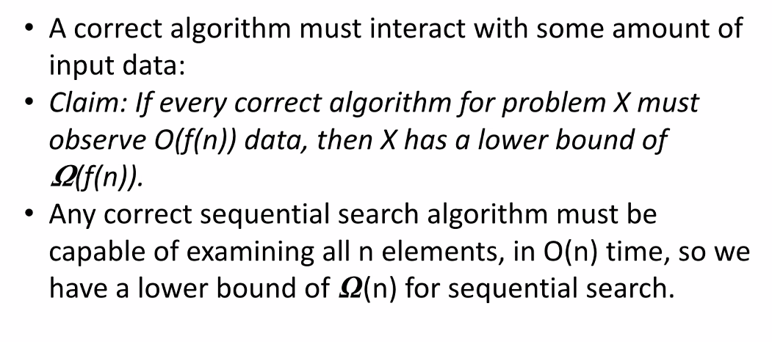
   3. Omega(n) shows lower bound by n of n
6. Tight bound for sorting
   1. 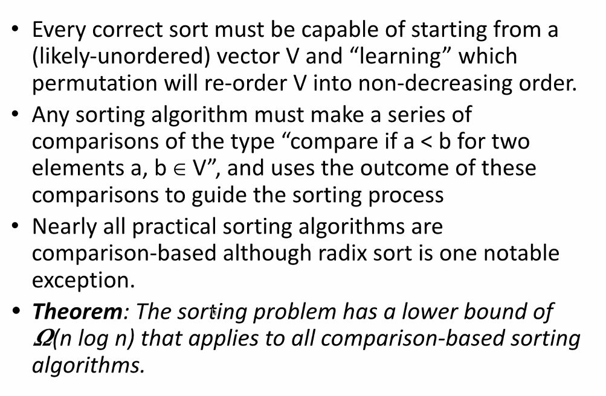
   2. In order to sort, you must compare the elements
   3. Linear time = only non comparison based sort
7. Example 2
   1. 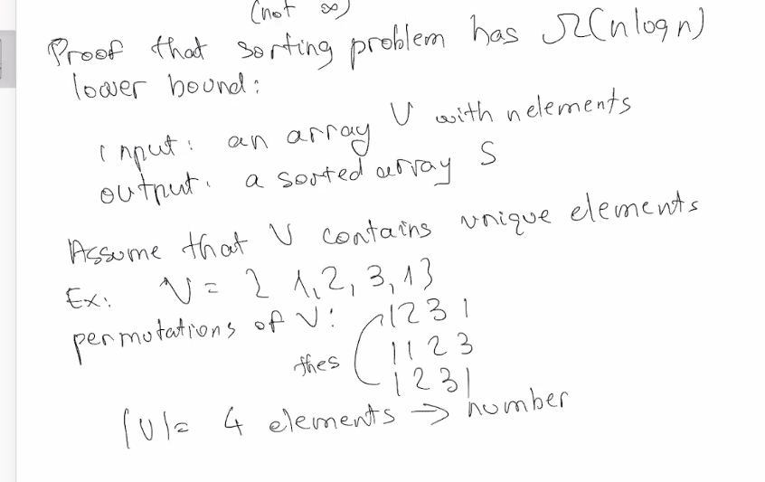  
      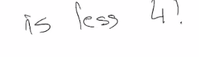
   2. In order for proof to work, we must have 4 elements and contain unique elements
   3. If contain unique elements, the sorted array is a permutation of V with elements in sorted order
   4. 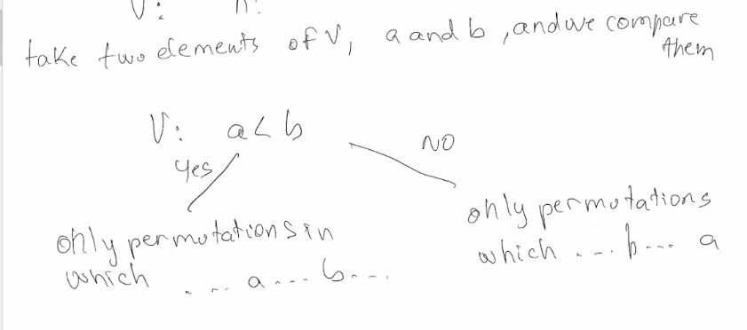
   5. 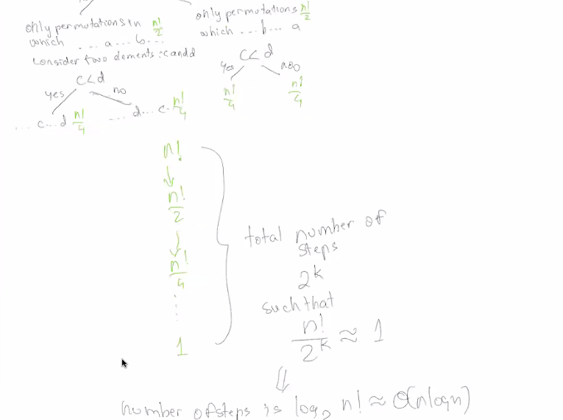
8. Little-O Notation  
   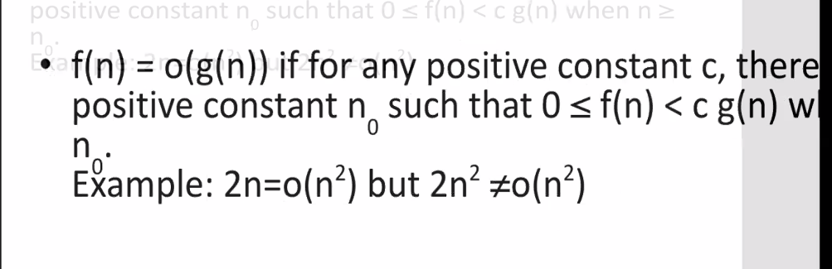
   1. General Computational problem  
      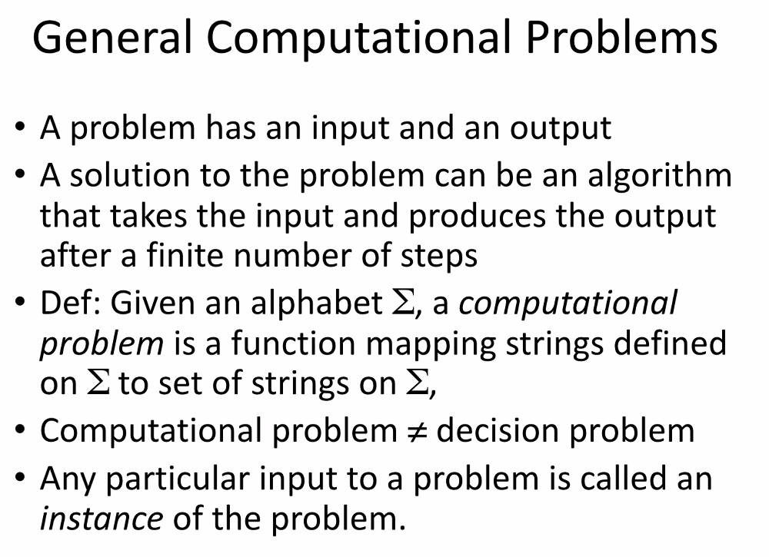
   2. Categories  
      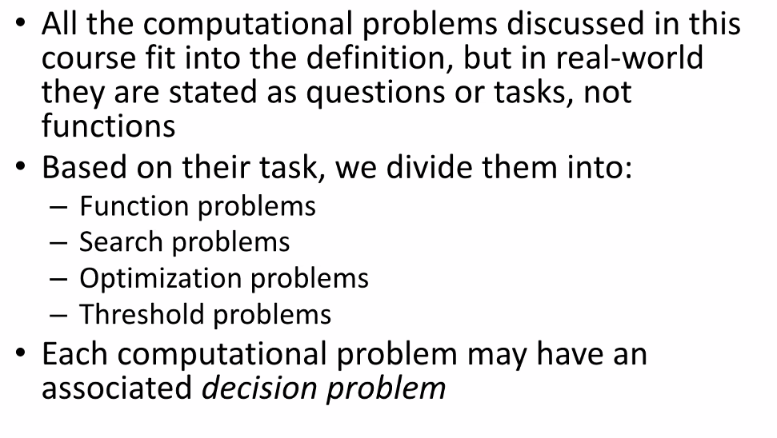
   3. How it works?  
      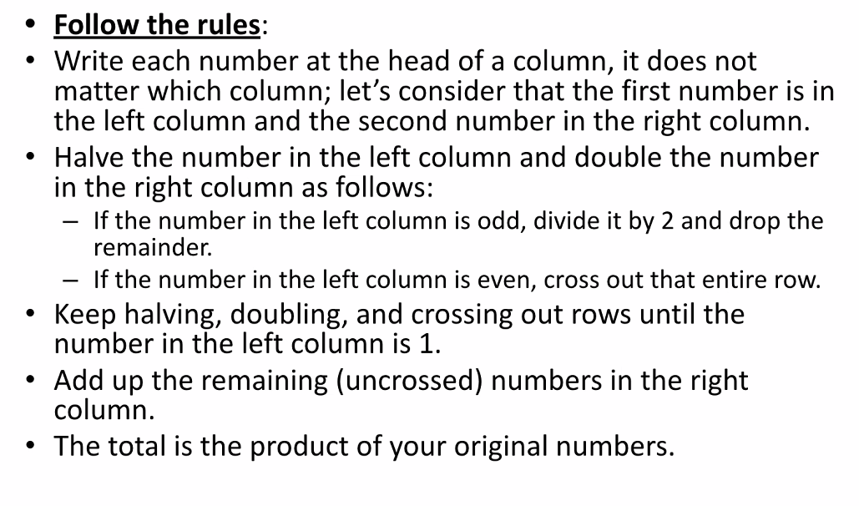
   4. 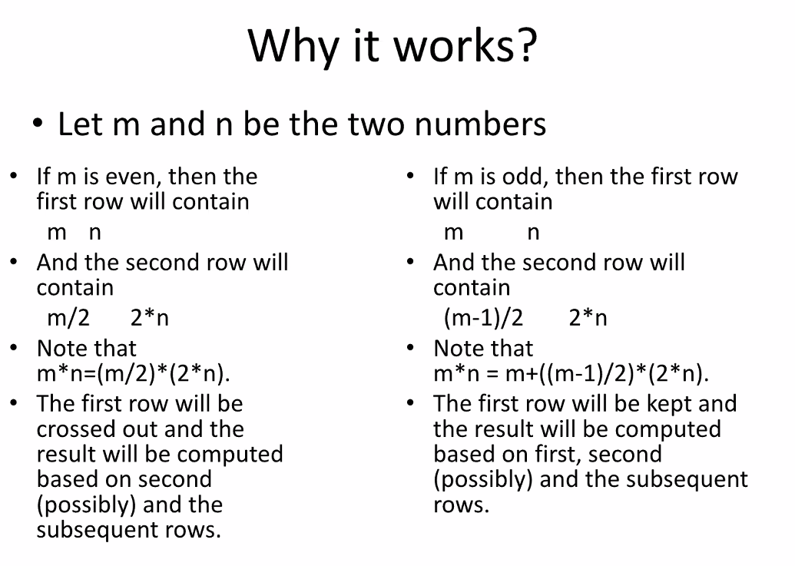
9. Example 1:   
   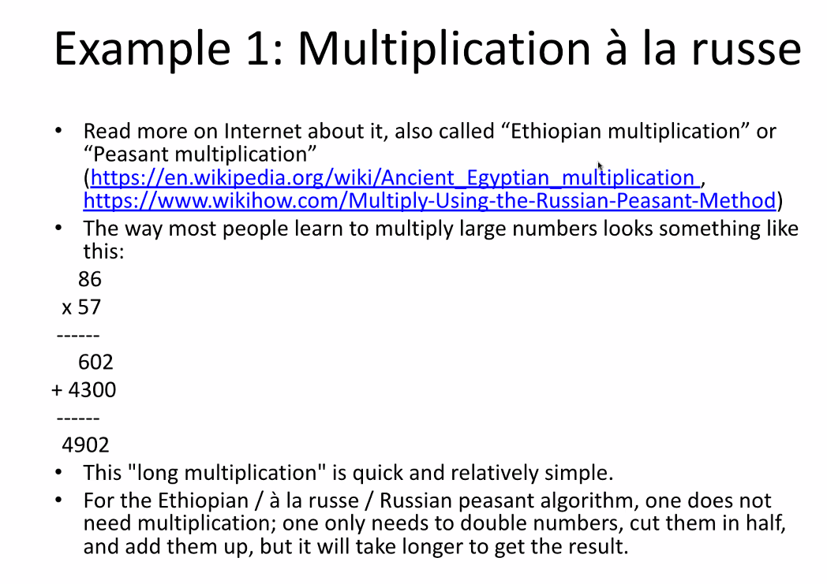
   1. If odd, go   
      If even, stay  
      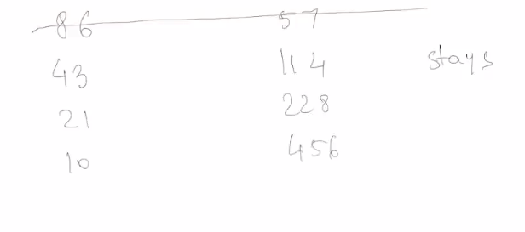  
      
10. Example 2: Lattice Multiplication  
    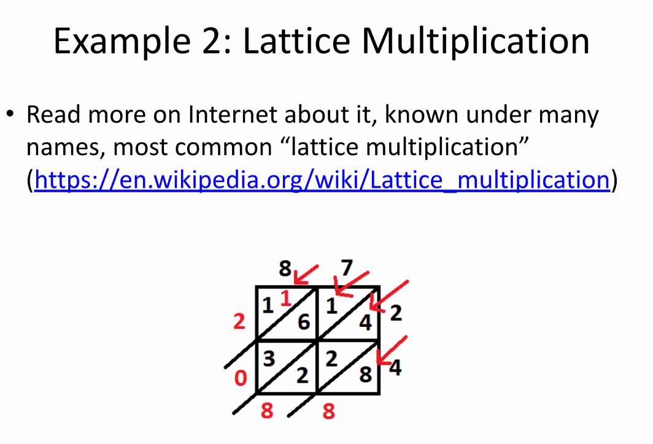
    1. 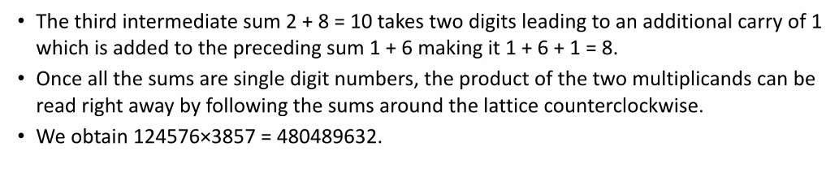
    2. 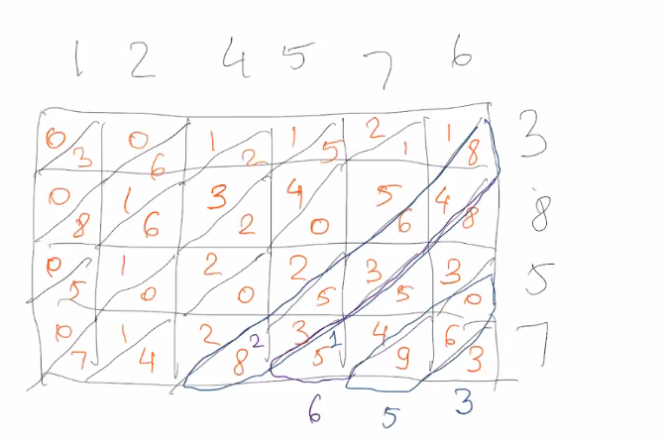
11. Search Problems  
    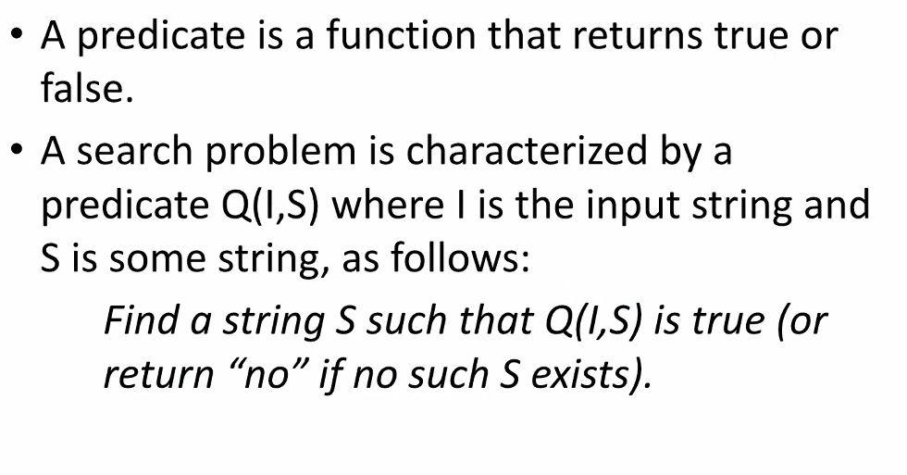
12. 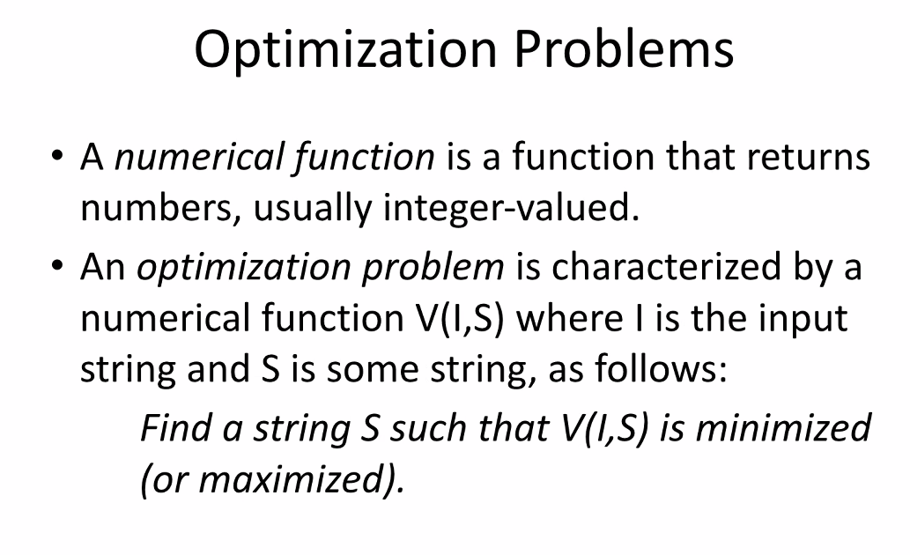
    1. No examples for this
13. Threshold Problems  
    